NAME: GAURAV GARG

UID: 22BCS15846

SECTION: FL_IOT_603-A

ASSIGNMENT: 4

1763.[Longest Nice Substring](https://leetcode.com/problems/longest-nice-substring/description/)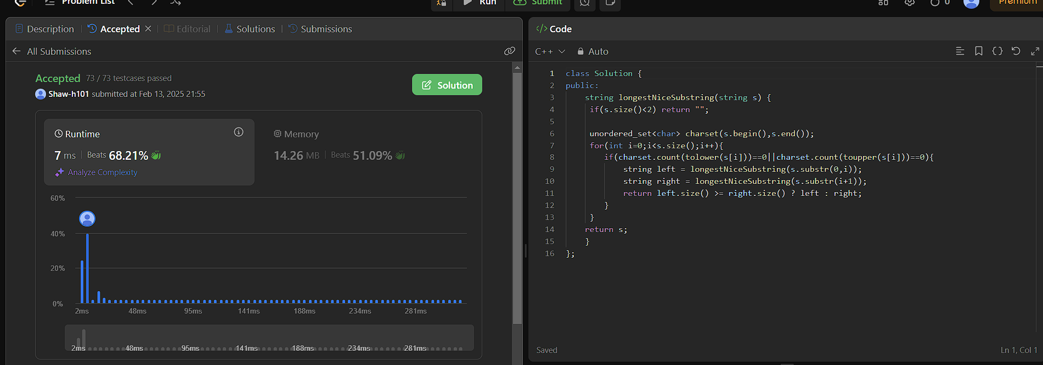

190.[Reverse Bits](https://leetcode.com/problems/reverse-bits/description/)

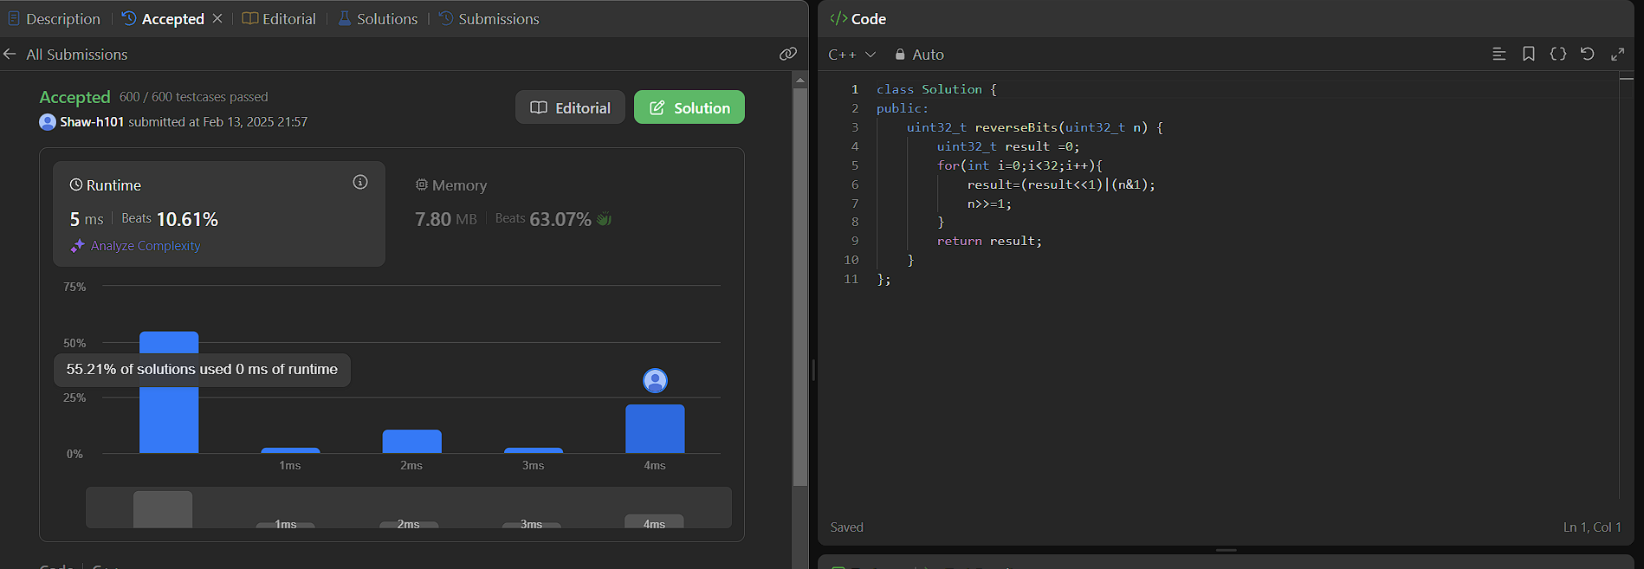

191.[Number of 1 Bits](https://leetcode.com/problems/number-of-1-bits/description/)

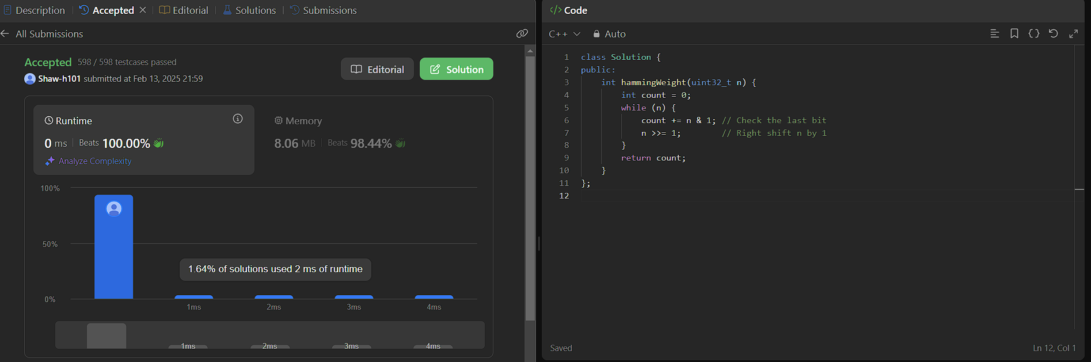

53.[Maximum Subarray](https://leetcode.com/problems/maximum-subarray/description/)

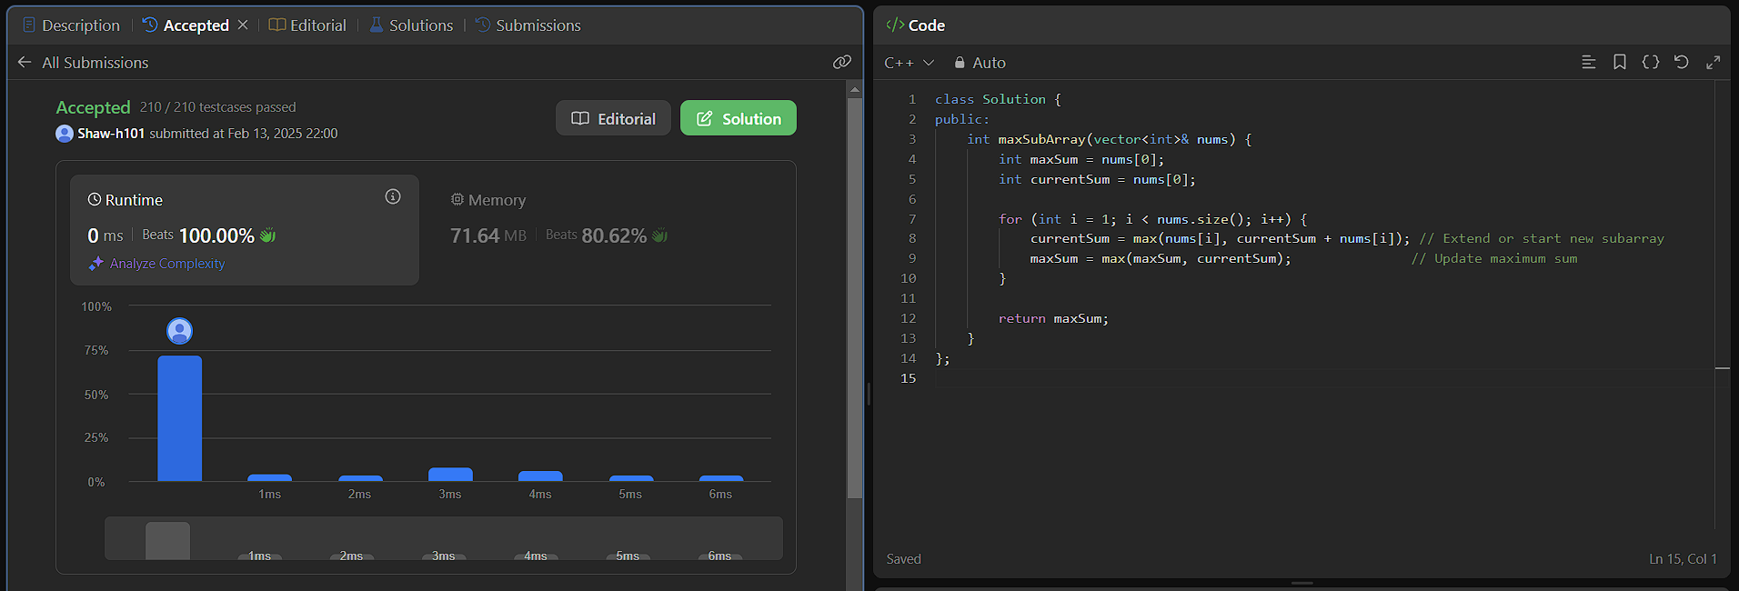

240.[Search a 2D Matrix II](https://leetcode.com/problems/search-a-2d-matrix-ii/description/)

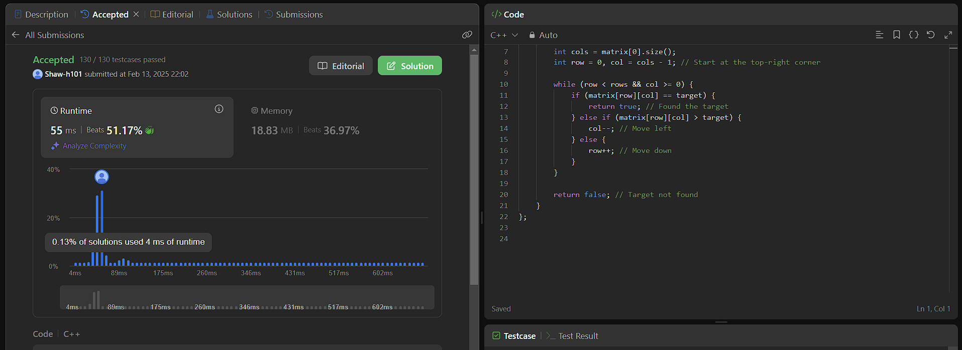

372.[Super Pow](https://leetcode.com/problems/super-pow/description/)

